LED tutorial

# Manufacturing

### Parts list:

|  |  |  |  |
| --- | --- | --- | --- |
| Part | Amount | Notes | Image |
| Adafruit DotStar Digital LED strip | 1 | <https://www.adafruit.com/product/2240?length=1> | Adafruit DotStar Digital LED Strip - White 60 LED - Per Meter - WHITE |
| Ribbon wire | ~3 ft | We used black, grey, white, and purple wires. | Image result for ribbon wire |
| 4-pin header | 1 | Part number: WM9131-ND | Image result for WM9131-ND |
| Silicone glue | 1 | <https://www.grainger.com/product/406W20?gclid=CjwKCAjwvJvpBRAtEiwAjLuRPZ_Sl7sjaj8k1NH8XQdIhp3zyGGysJu4nPp_T-i7-aUdAsLFmiFH5xoCrLIQAvD_BwE&cm_mmc=PPC:+Google+PLA&ef_id=CjwKCAjwvJvpBRAtEiwAjLuRPZ_Sl7sjaj8k1NH8XQdIhp3zyGGysJu4nPp_T-i7-aUdAsLFmiFH5xoCrLIQAvD_BwE:G:s&s_kwcid=AL!2966!3!281733020561!!!g!427397951721!> | White Sealant, Silicone, 2.8 oz. |

### Steps:

1. Measure and cut the LED strand and ribbon wire to the correct lengths based on the drawing below. Every time you cut the strand, you’ll lose one LED, so be careful when measuring.

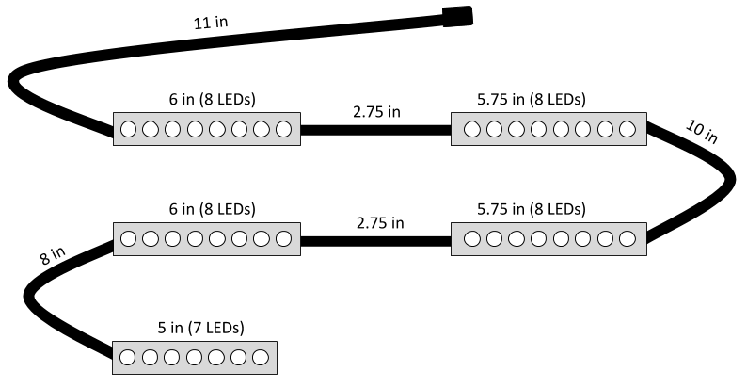

These are the measurements we used to make the LED strand one continuous piece. The black lines represent the ribbon wire. The 6 in LED strips are for the back side panels, the 5.75 in strips are for the front side panels, and the 5 in strip is for the top panel.

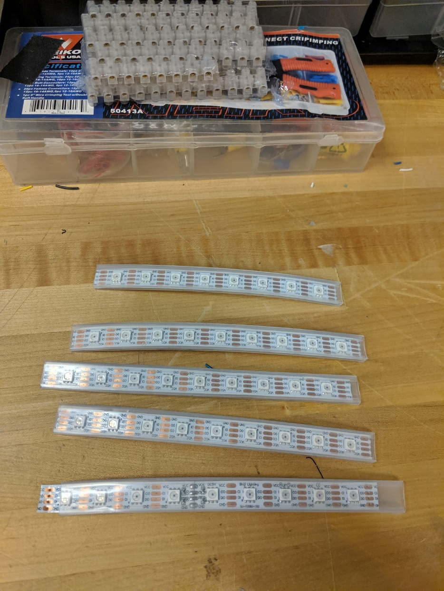

*This is what the strands should look like after they’ve been cut.*

1. Use a tack or other wire to make the holes in the LED strip larger so it will be easier to solder.

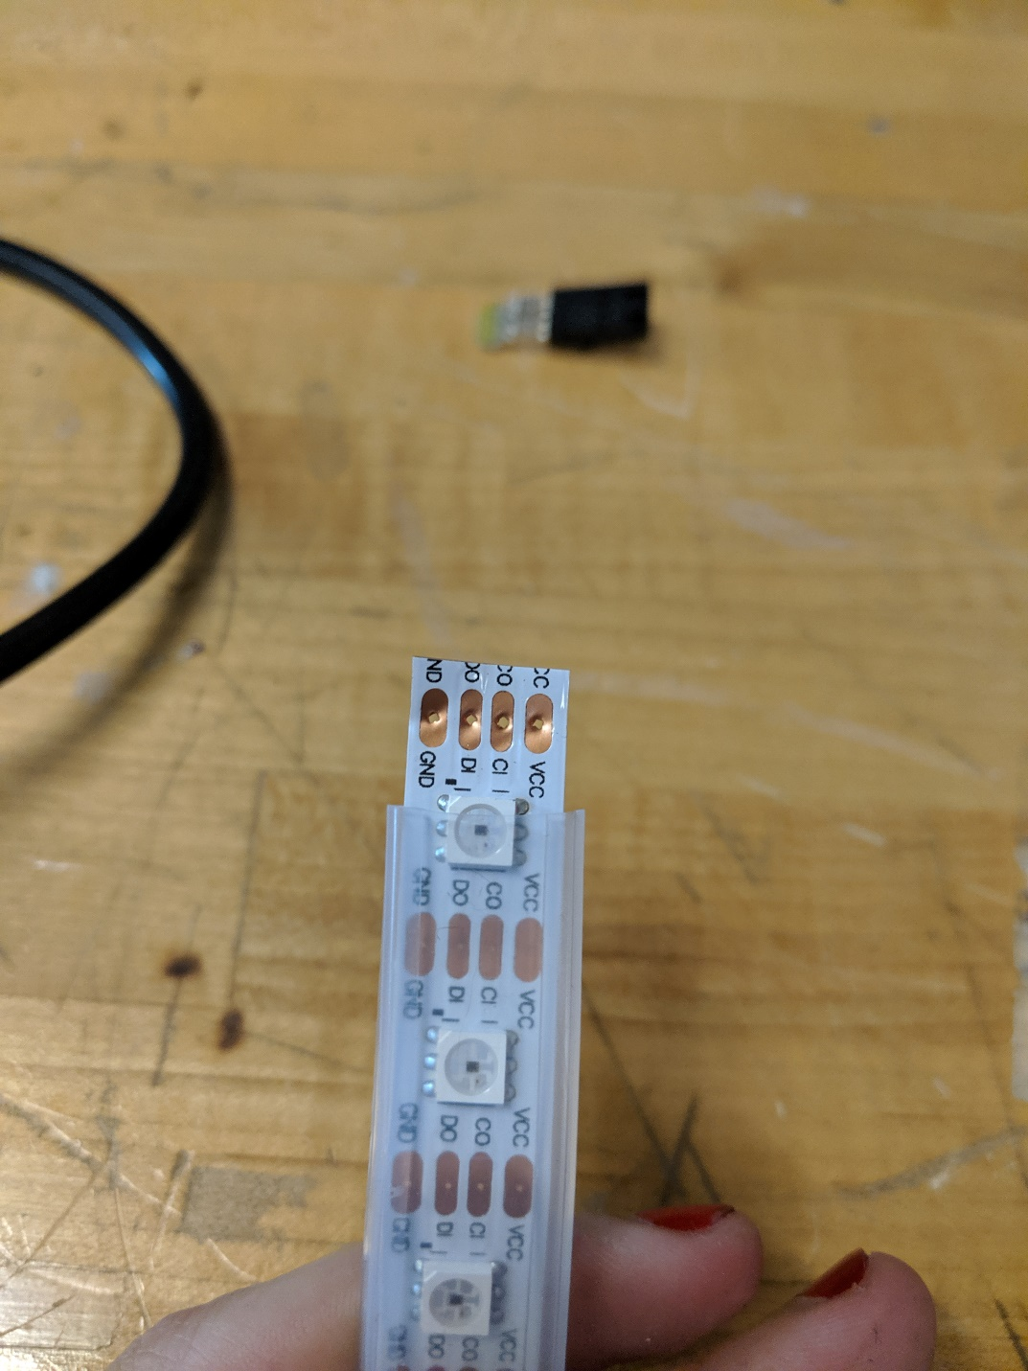

The top holes were enlarged by poking a wire through them.

1. Strip the ribbon wire, and insert the wires into the holes on the LED strip, and bend them so they stay still while you’re soldering. Try to follow the convention of black wire 🡪 GND. Also make sure to trim any free wire after you’re finished soldering.

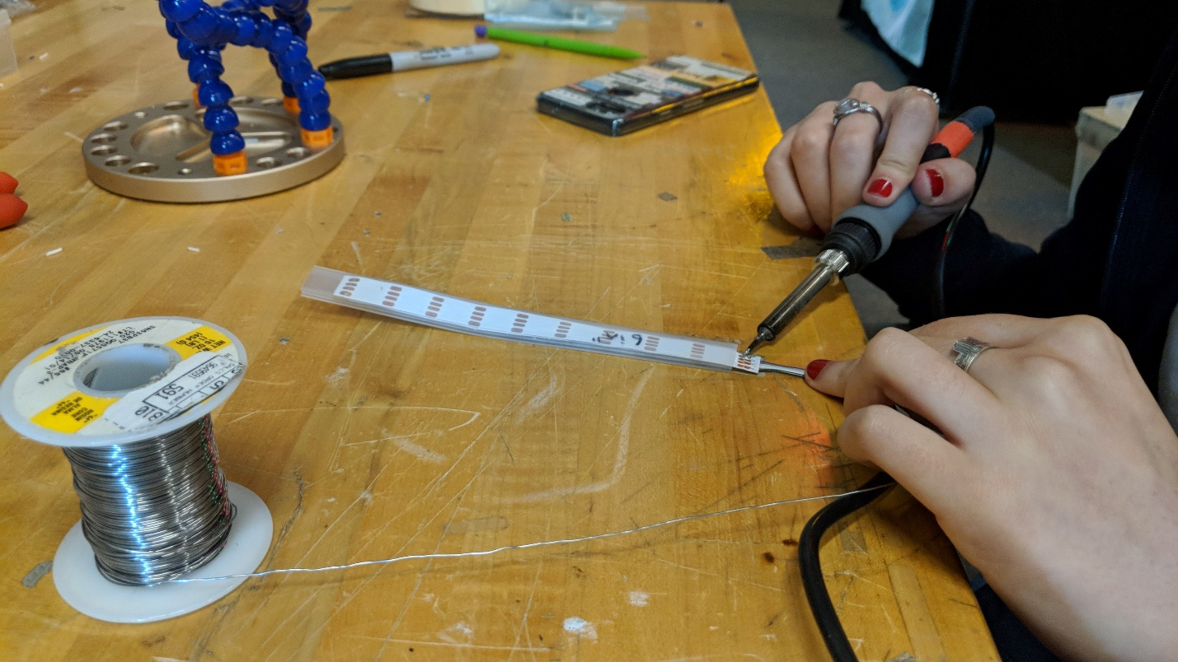

The wires are threaded through the top of the holes, then bent at the back so it’s easier to solder on the bottom. You can also solder on the top if wire is exposed.

1. Once everything is soldered together, double check that you’ve wired it correctly! If you accidentally switch VCC and GND, you can burn out the LEDs.
2. Test the strip!
3. After you’ve tested the strip, use silicone glue and seal the ends to make it watertight.

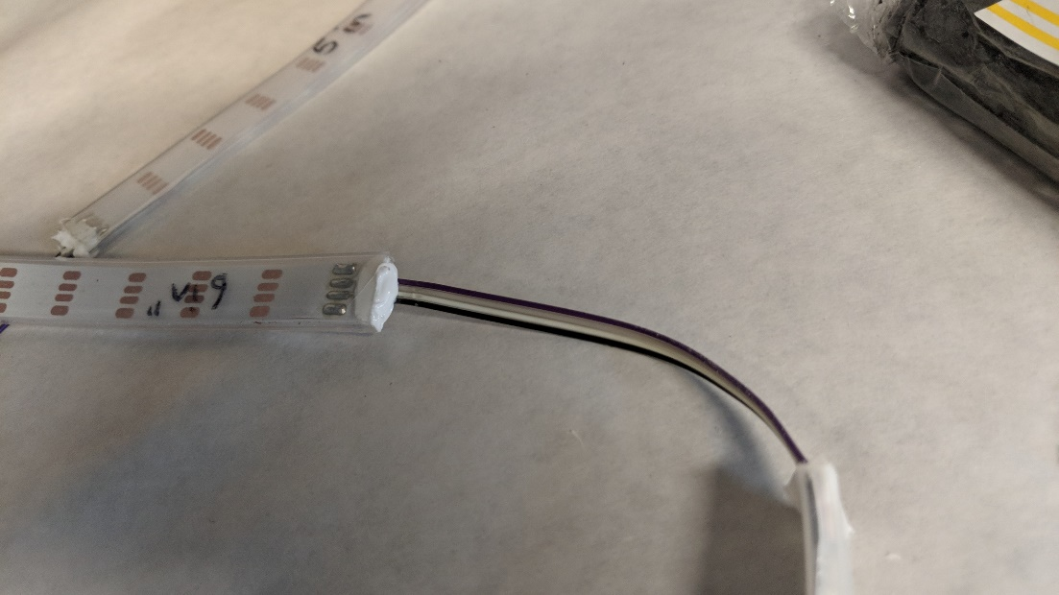

A sealed LED strip.

# Testing

Use the tester code which can be found at: “GitHub\seeboat\software\testing\LED." The LEDs should cycle through colors all the way down to the end of the strand. If it’s not working, add more solder, and make sure a battery is plugged into the Feather, as sometimes the LEDs are fussy and only work when you plug in a battery.

